ISSACK WAITHAKA
cs-sa07-24085

Python Basics

Introduction
- The first step was to start my machine which opened a code editor on a split screen

Hello world
- I was able to write my first line of python code

Questions
1.

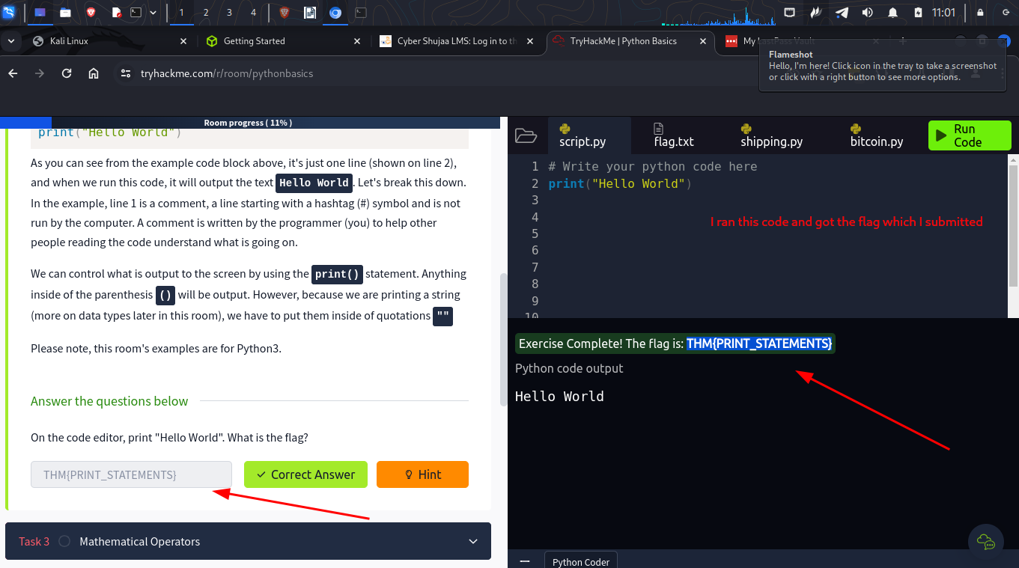

Mathematical operators
- Python also uses adding, subtraction and the basic mathematical operators
- There are also comparison operators like greater than, less than, equal etc

Questions
1.
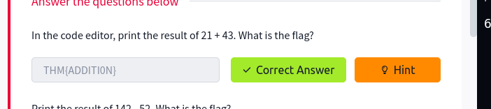
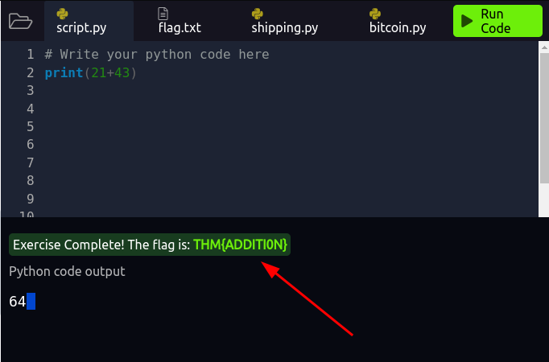
2.
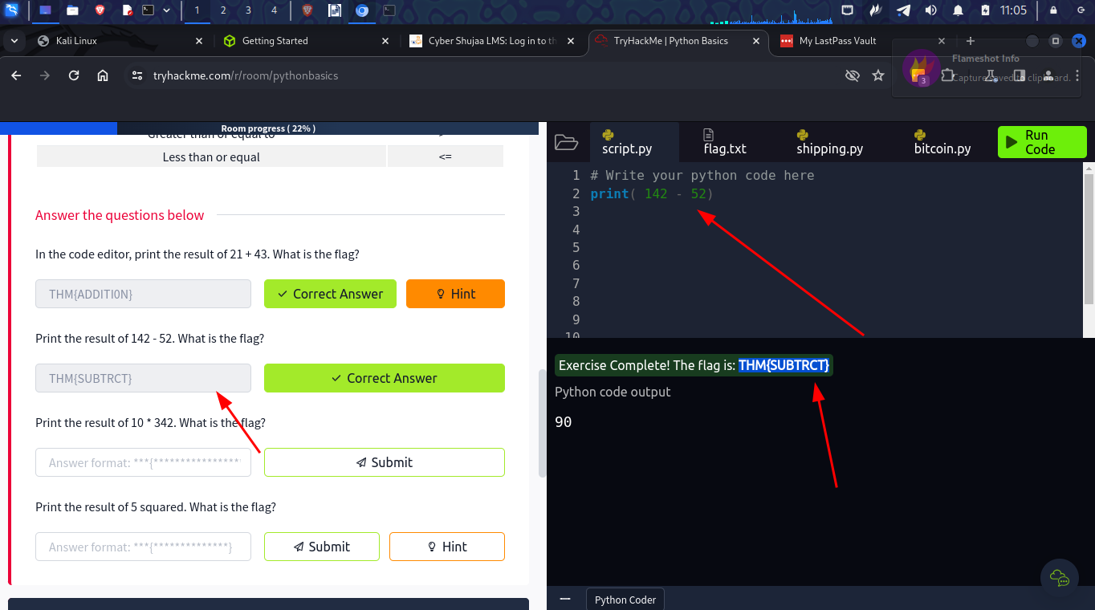
3.
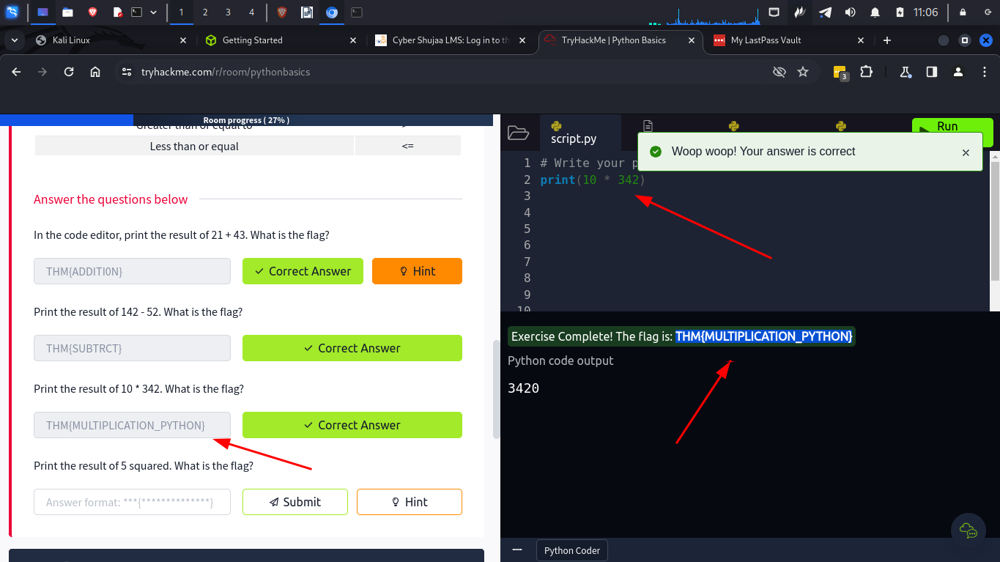
4.
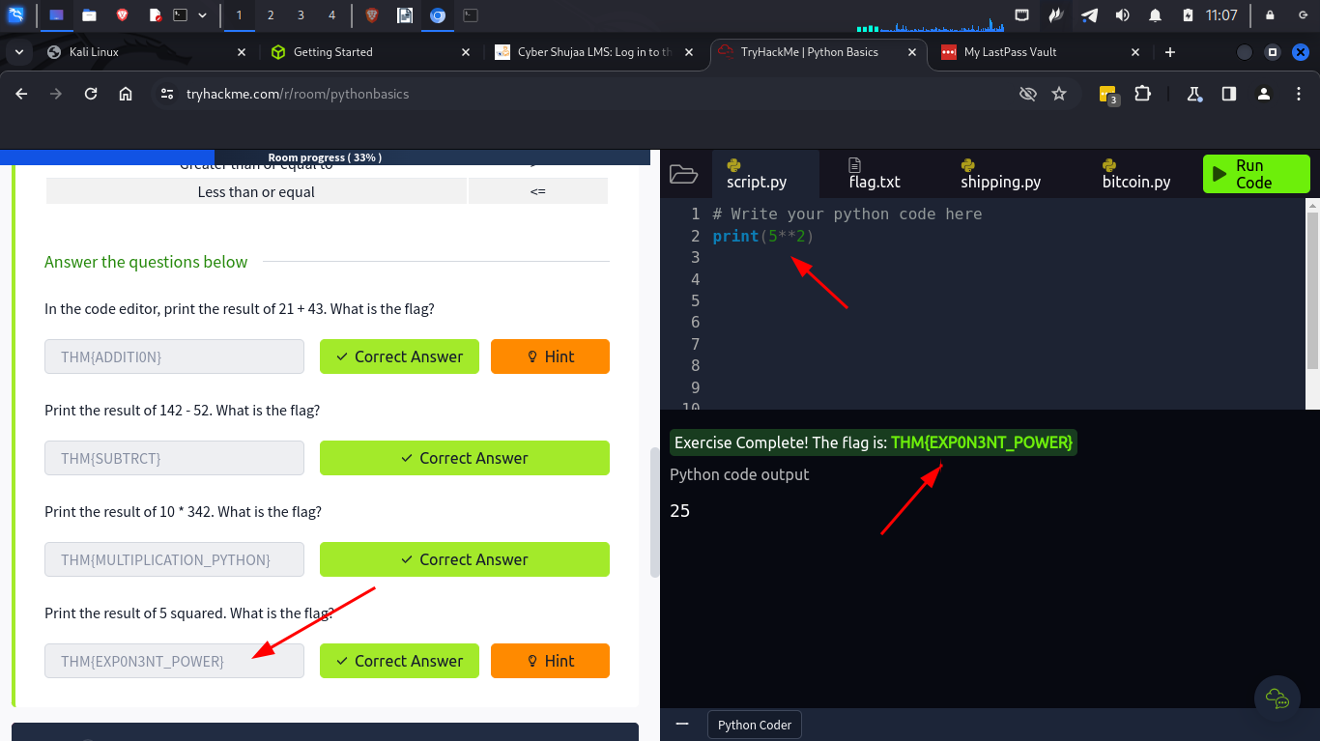

Variables and data types
- A variable allows us to store and update data
- They can be changed throughout your program
- Data types are types of data being stored in the variable
- They can include string, integers, float, etc.

Questions
1.
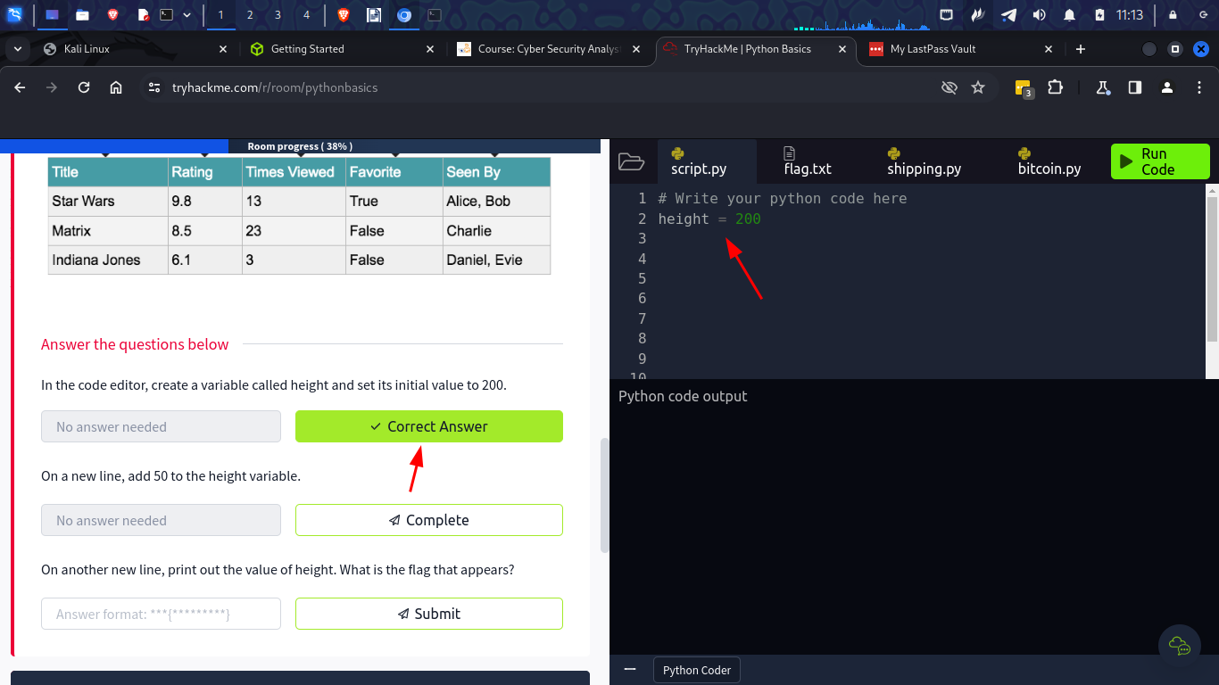
2.
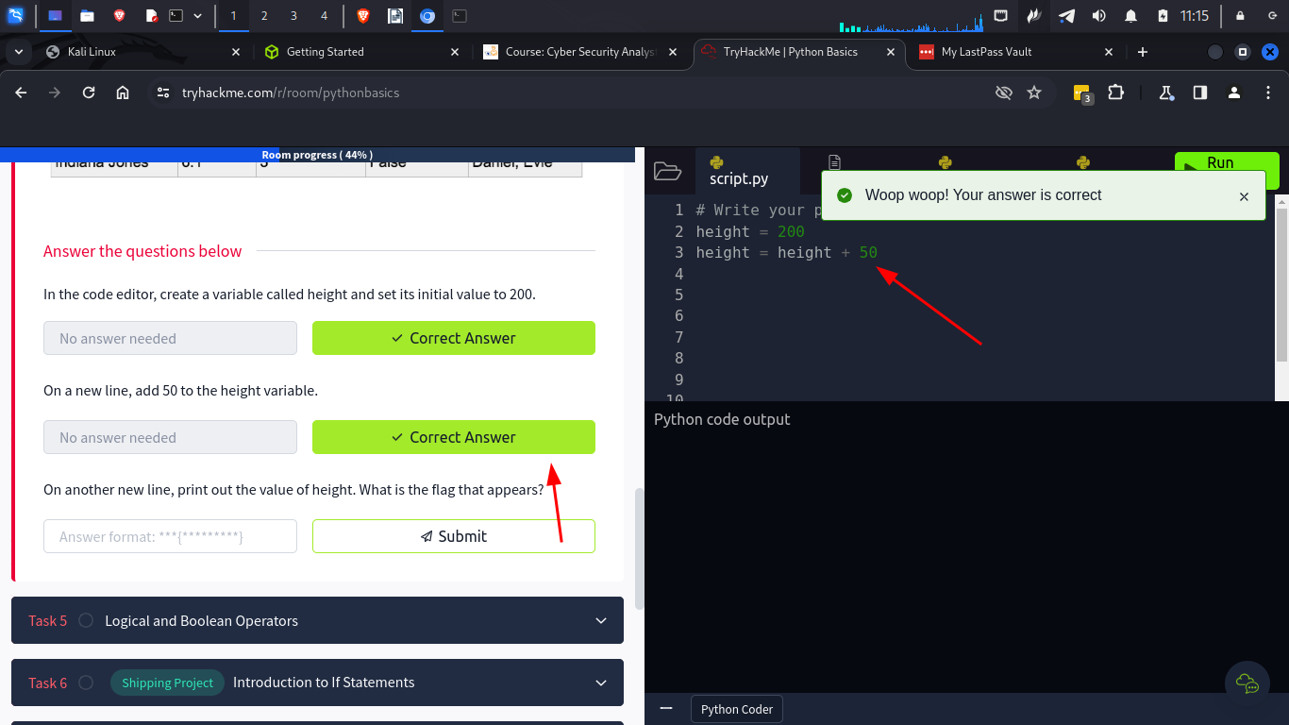
3.
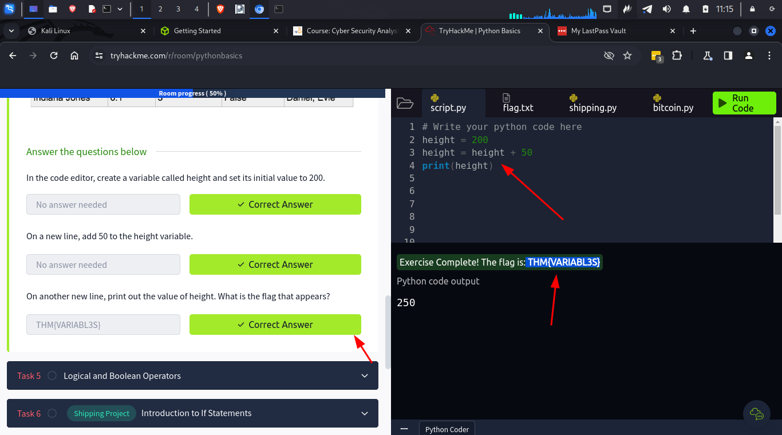

Logical and boolean operators
- Logical allows assignment and comparisons to be made and are used in conditional statements like less than, equal to, etc.
- Boolean are used to connect and compare relationships between statements

Introduction to if statements
- If allows programs to make statements

Questions
1.
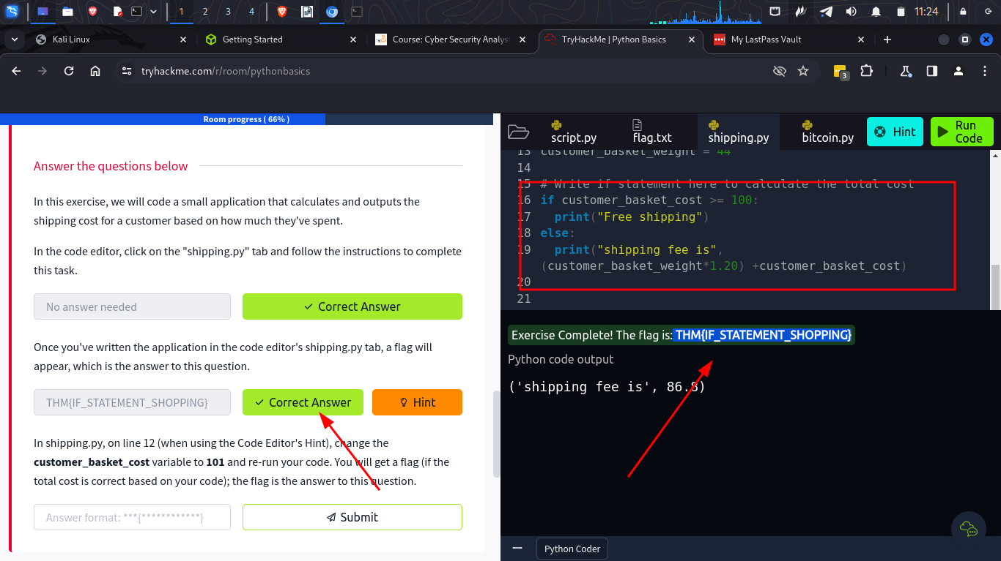
2.
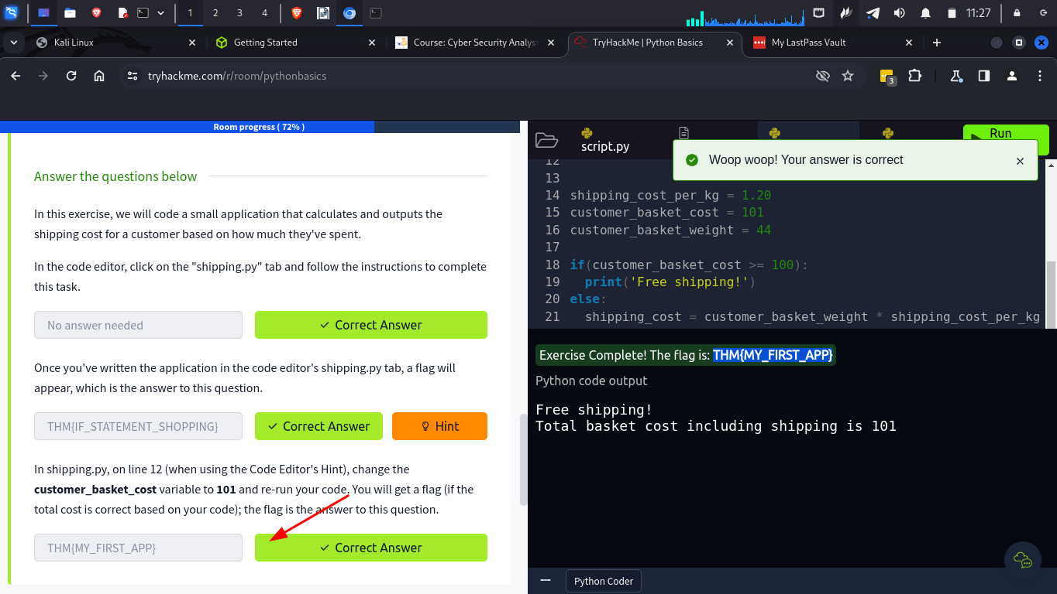

Loops
- A while loop can run indefinitely or a should be determined by a condition
- for loop is used to iterate over a sequence such as a list

Questions
1.
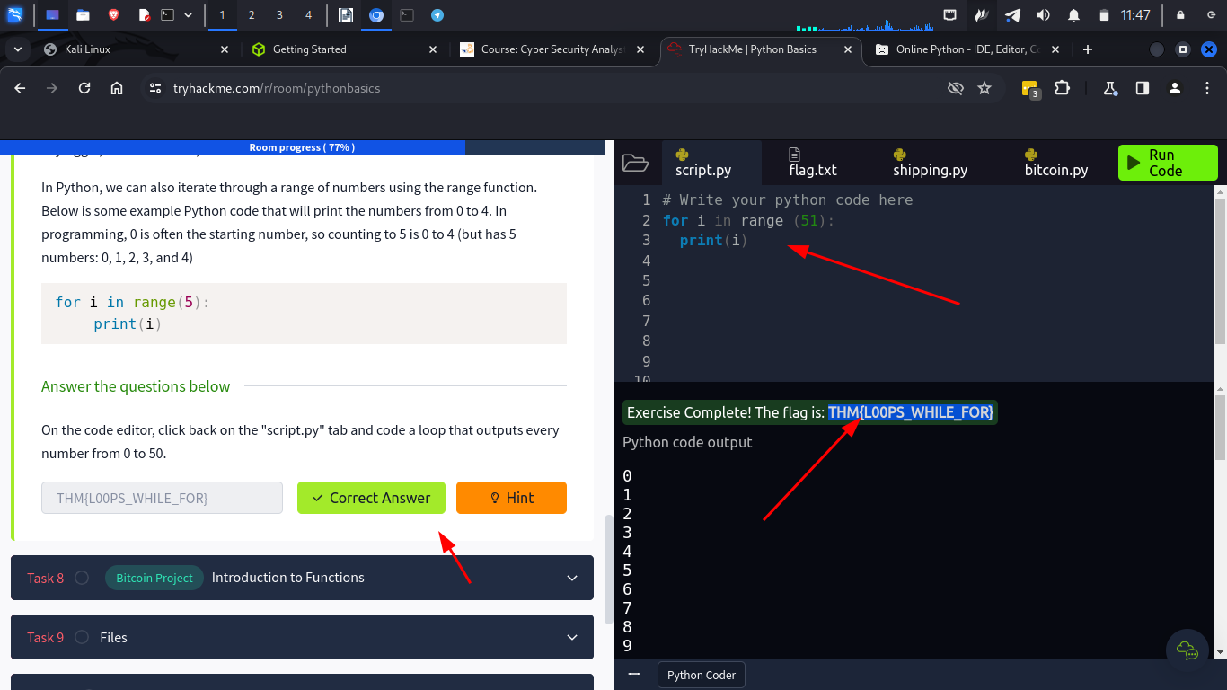

Introduction to functions
- A function is a block of code that can be called at different places

Questions
1.
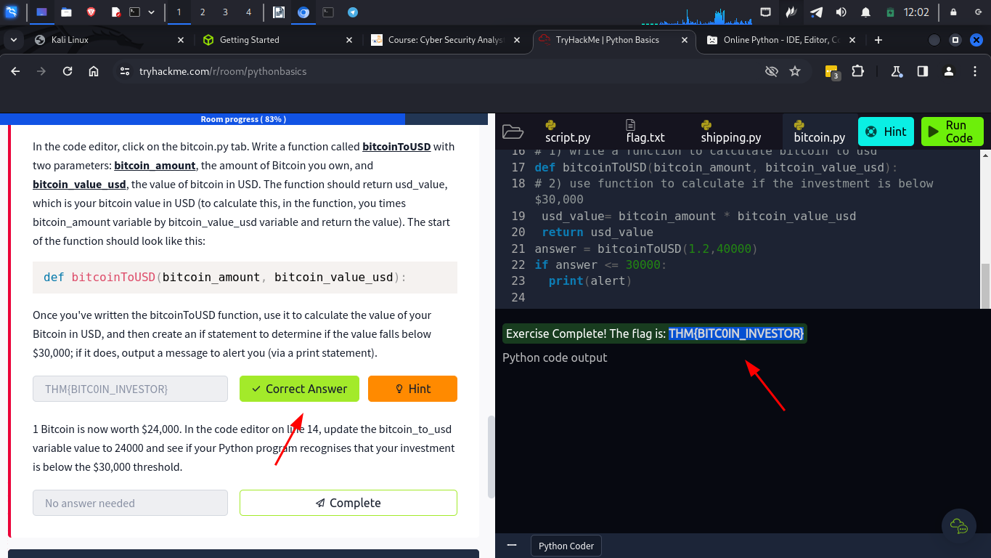

Files
- In python we can read and write from files

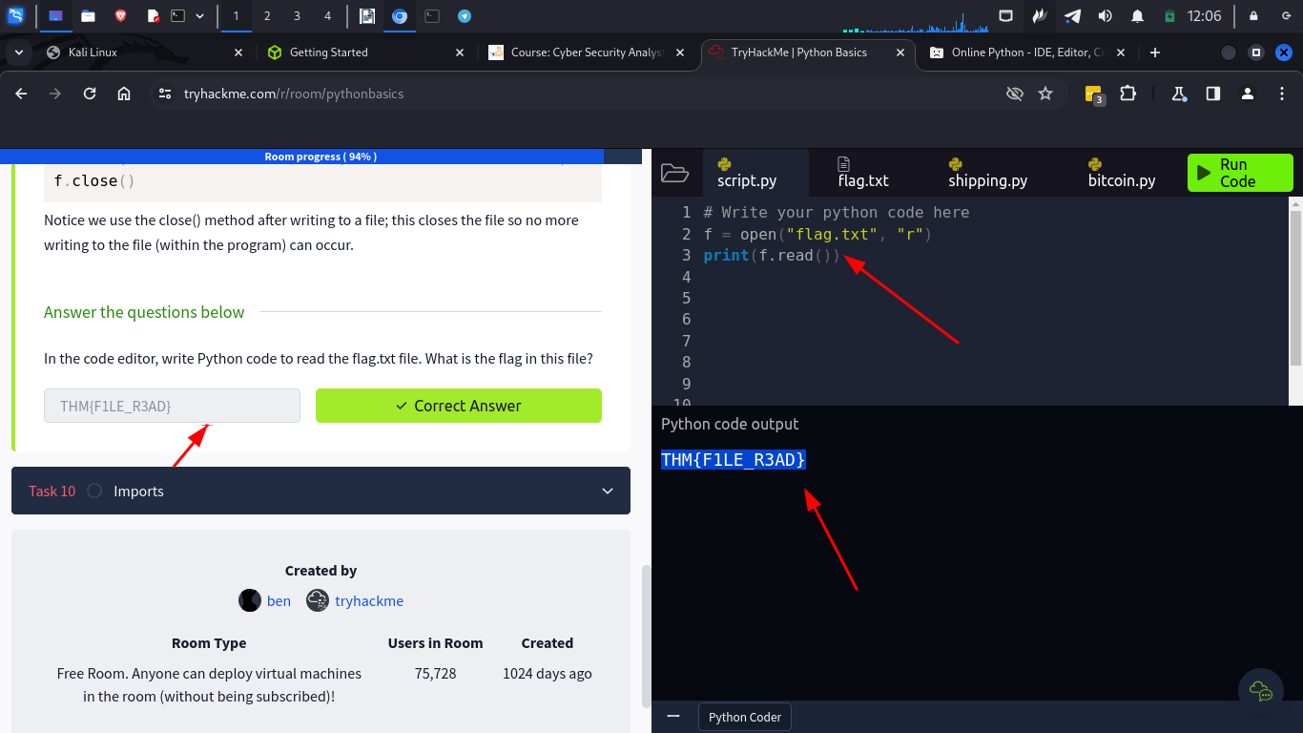
Imports
- We can import a collection of files that contain functions which are called libraries
- We import them using the import keyword

Conclusion

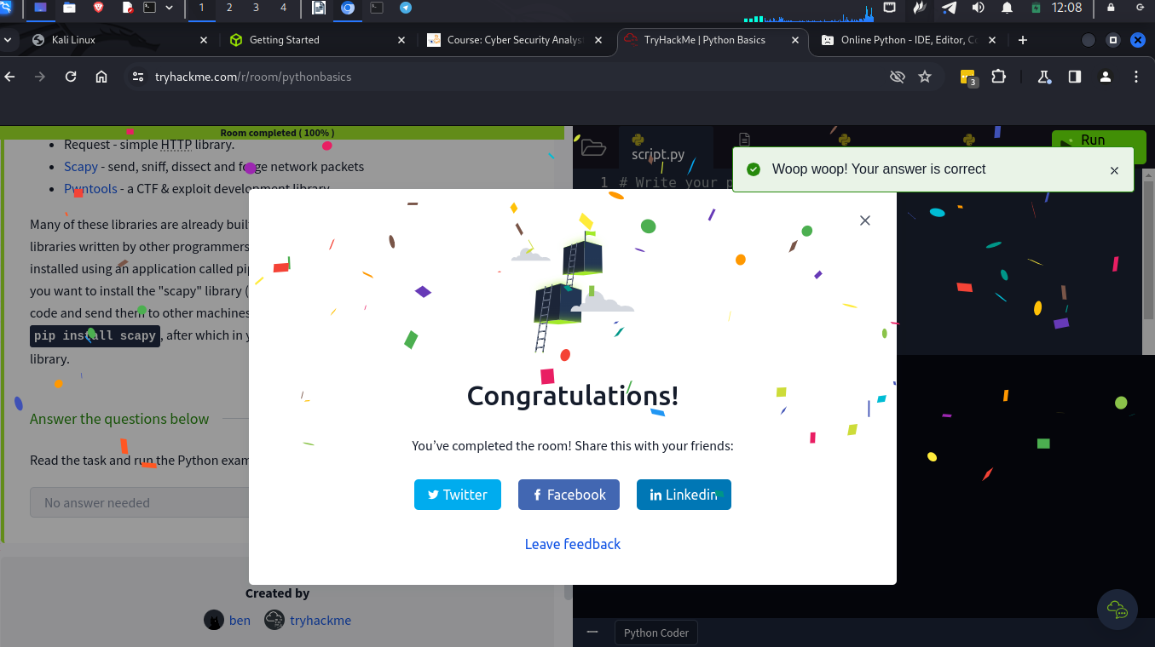
In this module I was able to write my first python codes. I learnt the basics of python and it was very enjoyable. I also learnt how python is used in Cyber security.

